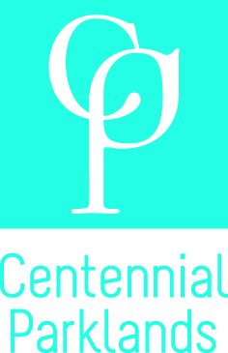
Community Consultative Committee

Application Form

- Applicant details

Name
Address
Phone
Mobile
Email

- Connection to Centennial Parklands

Describe your personal or professional connection to Centennial Parklands.

List relevant community groups or organisations that you have contact with that may assist you in your work as a CCC member and/or considering issues and activities relating to Centennial Parklands.

What is your role (formal or informal) with the above groups and how may this assist you and the Parklands in Committee matters?

3. Knowledge and Experience
Outline the strength of your knowledge and/or experience with community consultation processes (from a professional and/or personal perspective) and how this may benefit you in your role as a CCC Member.

Please outline your connection to, and knowledge of Centennial Parklands and how this will assist you in your role as a CCC Member.

Please provide a statement about how you would contribute to achieving the objectives of the Centennial Park and Moore Park Trust Act 1983 and contribute to the goals, mission and values of the Trust – as set out in its Strategic Plan 2015-2020.

4. Supporting Information
Applicants should attached a brief CV (maximum 5 pages) to complement your application. You may also attach additional pages to answer the above questions if the space provided is not sufficient.

5. Application submission
Applications should be submitted in writing by 5.00 pm, 8 November 2016 and addressed to:
Manager Communications & Public Affairs
Community Consultative Committee
Centennial Parklands
Locked Bag 15
PADDINGTON NSW 2021

Alternatively, they can be emailed to: info@centennialparklands.com.au

Please note, applications that do not address the questions above or do not include the requested supporting information may not be considered for interview.

